

Messaging Working Group

Tibco Enterprise Messaging Service
C++ Wrapper

Proposal Document

Version | 1.2
Date | March 29, 2004
Author | FirmWide IT Messaging Group
Status | Draft

Revision History
Version | Date | Author | Description
1.0 | March 17, 2004 | Keith Owen,  Solomon Fried | Original draft version of document.
1.1 | March 18, 2004 | Mark Blair | Document editing.
1.2 | March 23, 2004 | Keith Owen,  Solomon Fried | Document editing.

Table of Contents

1 Management Summary 1
1.1 Purpose of this Document 1
1.2 Scope 1
1.3 Constraints / Outstanding Issues 1
1.4 Next Steps 2
1.5 Supporting Documentation and URL Links 2
2 Current State of the C++ Wrapper 3
2.1 Common Interfaces 3
2.2 Message Types 4
2.3 JNDI Lookups 4
2.4 Supported Platforms 4
2.5 Usage Example 5
2.6 Comparison to the Tibco C API 5
3 Benefit/Drawbacks Analysis Of Using a C++ Wrapper 8
3.1 Benefits 8
3.2 Drawbacks 8
4 How Does the Wrapper Work 10
4.1 Overview 10
4.2 API Structure 10
4.3 Library Structure 11
4.4 C++ Wrapper Namespace 11
4.5 C++ Wrapper Implementation Lookup 12
4.6 C++ Wrapper Class Hierarchy 13
5 What does the Wrapper API Look Like 14
5.1 Asynchronous Subscriber Example 14
5.2 Publisher Example 17
6 Proposal 20
6.1 Summary 20
6.2 STL Support 20
6.3 Platform/Compiler Support 21
6.4 Enhancements 22
6.4.1 Add JNDI lookup from EMS 22
6.4.2 Support for the latest Tibco Release: EMS 4.0 22
6.4.3 Reconnect Logic 22
6.4.4 Clone Message 22
6.4.5 Proposal: Removal of the STL Dependency 22
6.4.6 Proposal: Re-Work SmartPointers 23
6.5 Documentation 23
6.6 Packaging and Distribution 24
6.7 Possible Future Enhancements 24
7 Appendix A: Class Internal Structure 25
7.1 Class Hierarchy 25
7.1.1 Message Class Hierarchy 25
7.1.2 Session Class 27

Management Summary

Purpose of this Document
This document presents a proposal for adopting the C++ wrapper developed by the Fixed Income IT Athena programmers as the C++ interface for enterprise deployment of Tibco Enterprise Message Service (EMS) 4.0 across the firm. First a technical review and analysis are presented in the following pages, followed by the proposal details in section 6. Tibco currently supports a Java, C# and a C API. Due to the complexity of supporting multiple compilers and platforms, the vendor does not currently (nor has any plans) to offer a C++ language binding. Since C++ is a primary language for software development within CSFB the C++ wrapper component is a key deliverable. The Firm-wide IT Messaging team is in the process of assuming ownership and responsibility for this wrapper, and this wrapper will form part of the phase-1 offering of EMS 4.0 slated for end of 2nd quarter of this year.
The intent of the document is to introduce the wrapper to participants of the Messaging Working Group (MWG), initiate discussion of the various issues raised in the document, and ultimately gain ratification across all business clusters in GAD represented in the MWG.
This document provides a technical overview of the current state of the Athena C++ wrapper along with the perceived benefits and drawbacks. It then presents to the reader an overview of how the API is structured internally and how it interfaces to their application. Next, it provides sample program excerpts using the C++ wrapper so that the reader is able to see how it fits into their application. And finally, it presents a proposal recommending it as the enterprise C++ interface for EMS. The proposal also details certain outstanding issues that need to be discussed with the MWG as a whole to come to a resolution regarding:
- Which environments do we need to target?
- Platforms / OS
- Compiler versions
- STL library variants (should we continue to use or eliminate?)
- Wrapper refinements / enhancements
- Usage of Reference Counted Pointers/Templates

Scope
This document focuses entirely on the adoption of the C++ wrapper and the issues pertaining to it.

Constraints / Outstanding Issues
A number of issues are presented in the document that will factor into the discussions within the MWG during the ratification process. These will be addressed in this forum.

Next Steps
- Distribute proposal to interested participants within the Messaging Working Group for review.
- Schedule an MWG follow up meeting shortly thereafter to obtain feedback on the proposal and discuss any comments or suggestions raised as a group. Attempt to reach a consensus as to what enhancements/refinements should be incorporated into the wrapper, if any, as well as determine what should be in scope for the phase-1 deliverable.
- Obtain ratification across all clusters represented in the MWG based on the agreed deliverable.
- Incorporate identified changes into the wrapper
- Package and Deploy with EMS for the Q2 phase-1 release.

Supporting Documentation and URL Links
- Athena Infocentre http://spri00630.corpny.csfb.com/Athena/index.asp
- Athena Architecture Assurance (AAA) recommendations and related documents (available under the Athena vob: /vob/athena.
- E4JMS for C++ - Original Athena C++ proposal document
ATHENA_GENERAL_DOCUMENTS/Documents/AAA/Decision Points/C++ Wrapper Recommendation.doc
- JMS wrapper architecture:
ATHENA_FRAMEWORK/Documents/JMS Wrapper Architecture.doc
- C++ STL – A comparison of STL libraries including some performance figures:
ATHENA_GENERAL_DOCUMENTS/Documents/AAA/Decision Points/STL and DB Wrapper recommendation.doc
- Sun JMS specification:
http://java.sun.com/products/jms/docs.html

Current State of the C++ Wrapper
The Fixed Income Athena programme was the first project within CSFB to evaluate and adopt Tibco E4JMS as their messaging architecture. The Athena Architecture Assurance (AAA) committee decided to implement a C++ wrapper to provide a very lightweight and easier to use, object-oriented interface to the Tibco E4JMS C client library. Since a large percentage of their applications are, or will be, written in C++, it was mandated that all of these applications be developed using this interface.
The Athena C++ wrapper interface is based on the Java JMS 1.1 specification, however, only a subset of the spec’s functionality is supported. In particular, the majority of the older JMS 1.0.2b specification topic/queue message domain specific API’s, such as QueueConnectionFactory and TopicConnection, have been omitted. Furthermore, functionality that is specific to the Java language binding was not implemented (e.g. StreamMessage and ObjectMessage). Where deemed necessary from a functional standpoint, some message domain specific components have been included, for example, the Queue and Topic destinations. Note that all functionality defined by the new 1.1 spec “common components” has been implemented.
Although the JMS 1.1 spec still supports the message domain specific interfaces, they are considered deprecated and it is highly recommended that the new “common component” interfaces be used for new development. For this reason as well as development time constraints, the C++ wrapper comprises the new components only. The following sections outline the JMS components implemented and omitted in the wrapper.

Common Interfaces

PTP Domain Interfaces | C++ Wrapper Support | JMS Common Interfaces (Preferred) | C++ Wrapper Support
QueueConnectionFactory | No | ConnectionFactory | Yes
QueueConnection | No | Connection | Yes
Queue | Yes | Destination | Yes
QueueSession | No | Session | Yes
QueueSender | No | MessageProducer | Yes
QueueReceiver | No | MessageConsumer | Yes
QueueBrowser | Yes
QueueRequestor | No

Pub/Sub Domain interfaces | C++ Wrapper Support | JMS Common interfaces (Preferred) | C++ Wrapper Support
TopicConnectionFactory | No | ConnectionFactory | Yes
TopicConnection | No | Connection | Yes
Topic | Yes | Destination | Yes
TopicSession | No | Session | Yes
TopicPublisher | No | MessageProducer | Yes
TopicSubscriber | Yes | MessageConsumer | Yes
TopicRequestor | No

Message Types
The standard JMS Message Types that are supported in the C++ Wrapper are:

JMS Message Type | C++ Wrapper Support | Notes
Message | Yes | A message containing no body.
TextMessage | Yes | A text message such as XML.
MapMessage | Yes | A set of name value pairs
BytesMessage | Yes | A stream of bytes.
StreamMessage | No | A stream of Java primitive values. Implemented in the “C” API but not in the wrapper due to the Java specific nature.
ObjectMessage | No | A message that contains a Serializable Java object.

NOTE
Because of the Java specific encodings within the JMS StreamMessage and ObjectMessage, it was decided to omit them from the C++ wrapper

JNDI Lookups
The C++ wrapper does not expose access to the JNDI interface (available in the C API) for externalizing connection and destination parameter information. The C++ wrapper supports the Destination and ConnectionFactory classes; however, the application must set properties in these objects rather than the property settings coming from a JNDI, so the benefit of being able to externalize information is lost. It in recommended that the firm wide release of the wrapper contain support for a JNDI lookup feature; possibly using LDAP or the existing built-in EMS provided local JNDI.
Naming Library
The C++ wrapper does provide a “Naming” library that is used to dynamically load a specific underlying transport implementation of the C++ wrapper (i.e. an implementation constructed for EMS or MQSeries). At the moment there is only an implementation for EMS but conceivably in the future an implementation could be built for MQSeries or Foboca, thus providing a common service API layer for all required messaging transports. This “Naming” library is unfortunately inaccurately labeled. It is really a dynamic loader for the underlying transport wrapper and not a JNDI lookup feature. The dynamic loader is nevertheless a useful feature of the API. A true JNDI interface, though, needs to be exposed for completeness of the wrapper and to enable external configuration. Note that the C API already provides this functionality.

Supported Platforms
The Athena C++ wrapper is currently supported on:
- Solaris 2.8
SunPro 5.3 compiler
STLPort 4.5.3 and RogueWave SourcePro ED4 STL libraries.
- Windows NT / 2000
Visual Studio Version 6 Compiler
STLPort 4.5.3 and RogueWave SourcePro ED4 STL libraries.

Usage Example
Using the C++ wrapper is very similar to Java. The class and method names are identical:

// Example using C++ Wrapper

Session mySess = myConn->createSession (false,
Session::AUTO_ACKNOWLEDGE);

// Example using Java interface

Session mySession = myConn.createSession (false,
Session.AUTO_ACKNOWLEDGE);

Comparison to the Tibco C API
This section indicates differences between the Tibco C API and Athena C++ wrapper. Note that where functionality maps directly between the two the information has been omitted for brevity (i.e. you can assume that if not specified here, it is fully supported in the C++ wrapper).
Some differences exist between the functionality of Tibco’s C API and the Athena C++ wrapper. The differences can be classified as:
- Equivalent functionality, however, different syntactical representation
- Omission of functionality in the C++ wrapper existing in the C API
Some of the C API functions are better represented in C++ using C++ language facilities. For example, the C API CreateCopy( ) would be implemented as a standard C++ copy constructor or assignment operator. Also, methods such as DeleteObject( ) are not implemented but are destroyed when the object goes out of scope, or when a delete on the object is performed.
The message domain specific components, such as QueueSession and QueueSender, are not explicitly implemented. The functionality is provided through the generic Session and Producer classes.
Also, as detailed in Section 2.1 (Common Interfaces), the domain specific classes such as QueueSender, QueueReceiver, TopicPublisher and TopicRequestor have been replaced with the “common component” interfaces (MessageProducer and MessageConsumer) as recommended by the JMS 1.1 specification.
The two domain specific classes that remain in the C++ Wrapper are QueueBrowser and TopicSubscriber. These remain in order to support specific methods of the Session object that are not otherwise implemented. The methods are;
- Session.createDurableSubscriber(…)
This returns a TopicSubscriber for durable subscriptions.
- Session.createBrowser()
Returns a QueueBrowser which supports the non-destructive reading of messages off a queue.

It should be noted that the goal of the C++ Wrapper was to provide functionality similar to the JMS Java specification as well as simplifying the C API in an easier to use interface. The C++ Wrapper largely accomplishes this goal.

Tibco C API | Athena C++ Wrapper | JMS Spec | Comments
Category/Class: JMS_Message
Print( ) | Operator<< overload | Supported | The C Print( ) function for all components is supported using the operator<< streaming operator.
Get/Set Encoding | Not supported?? | Not part of spec? are we sure this isn’t represented somehow in the spec and Java language binding?
GetAsBytes | Not Supported | Not Supported
CreateFromBytes | Not Supported | Not Supported
Make Writable | Not Supported | Not Supported
Category/Class: JMS_MapMessage
Get/SetBytes | Not Supported | Supported
Get/SetMapMessage | Not Supported | Not Supported
Get/SetReferencedBytes | Not Supported | Not Supported
Category/Class: JMS_MessageProducer
SendEx( )  SendToDestination( ) | Send( ) method overloads | Supported | Usage of C++ method overload capability to represent C function variants.
Category/Class: JMS_QueueBrowser
GetNext | getEnumeration | Supported as getEnumeration | JMS Enumeration browses messages in the order they would be received.
Category/Class: JMS_Connection
CreateSSL | Not Supported | Not Supported
Category/Class: JMS_ConnectionFactory
CreateConnectionSSL | Not Supported | Not Supported

Tibco C API | Athena C++ Wrapper | JMS Spec | Comments
Category/Class: JMS_SSL…..
 | Not Supported | Not Supported | Non of the C API SSL functions are supported in JMS or in the C++ API.
Category/Class: JMS_Session
CreateStreamMessage | Not Supported | Supported | Streams Java primitive types. Is it usefull for C++ application?
Category/Class: JMS_StreamMessage
StreamMessage calls | Not Supported | Supported | Contains a serialized stream of primitive Java Types.  The C++ Wrapper contains a MessageWriter class that supports basic streaming of messages but does not mimic the StreamMessage interface.
Category/Class: JMS_ObjectMessage
 | Not Supported | Supported | ObjectMessage contains a serialized Java Object.
Category/Class: JMS_ObjectMessage
Get/Set Encoding | Not supported | Not supported

Benefit/Drawbacks Analysis Of Using a C++ Wrapper

Benefits
The proposed C++ Wrapper provides a number of benefits including:
- Consistent interface. By standardizing on a well-thought out, easy to use object oriented interface consistent with the JMS spec, this should reduce the tendency of different application teams writing their own wrappers.
- Housekeeping. The automatic closing of handles, connections, topics, messages, locks etc via the class destructor mechanism.
- Memory management. Automatic memory management through use of reference counted pointers. By contrast, the Tibco C API requires the programmer to explicitly close handles and free storage. The failure to perform these steps is a common cause of memory leaks in applications. With the C++ wrapper, the programmer is not required to explicitly free memory that is allocated by the API. This mimics the JMS interface under Java where the ‘garbage collector’ automatically recovers memory as required.
- Exception handling. C++ exceptions are thrown rather than relying on the C API return code. This makes for cleaner and more reliable code and is in-line with the JMS specification.
- Performance. Very thin wrapper amounts to an insignificant amount of run-time overhead. In some cases there may actually be a performance benefit or reduction in resource consumption due to the best practices exercised and encapsulated within the C++ classes that might not be followed by all programmers using the C API directly.
- Vendor isolation. The wrapper isolates the applications from the underlying JMS vendor. The vendor could conceivably be replaced within the wrapper without affecting the applications using it.
- Feature set. The wrapper offers the opportunity to provide value-added features such as strong authentication and improved resiliency through automatic reconnect logic.

Drawbacks
The following concerns were raised regarding the proposal:
- Cost. Additional cost of ownership for developing the wrapper API and supporting it.
- Functionality. Could potentially restrict the ability to realize the full functionality of Tibco’s C API. The wrapper exposes all of the functionality that its designers deemed necessary at the time to create a robust, full featured JMS application; however, there are a few instances where functionality in the C API exceeds that of the wrapper. Rather than have developers resort to augmenting functionality with the C API, the C++ wrapper could be extended to meet any additional requirements.
- Debugging. Adds complexity to application debugging. Developers debugging an application could step into the wrapper and they would be unfamiliar with the code within the wrapper (which is currently quite complex with the use of smart pointers and C++ templates).
- Library dependencies. STL dependency introduced by the current version of the C++ wrapper. This may greatly increase the number of builds required along with packaging and deployment demands.
- Portability. Value added features built into the C++ wrapper would result in loss of parity across all language bindings unless wrappers are provided for those other bindings.

How Does the Wrapper Work

Overview
This section presents an overview of the C++ wrapper structure and samples that illustrate its usage.

API Structure
The C++ Wrapper API is implemented as a shared library or dll and consists of a set of C++ classes. The abstract classes define a pure virtual interface that mirrors the Java JMS specification. A set of implementation classes derive from the abstract classes and translate the Abstract class methods to calls to the EMS C shared library. The diagram shows a number of these classes and a few of the functions in C API that they wrap. The C API functions are held in a shared library as shown below.
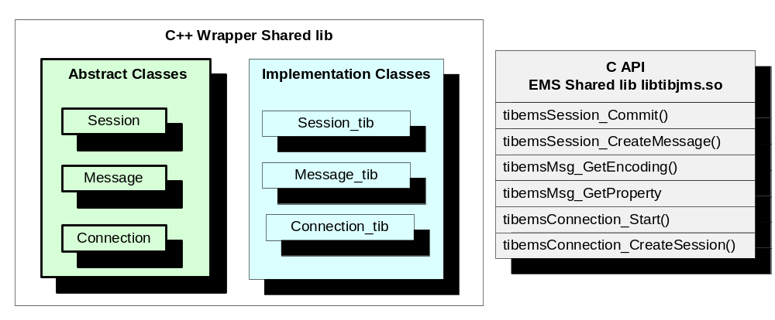
As an example of how the classes interact consider the Java JMS method call.

// Assume myConn is a valid Connection
Session mySess = myConn->createSession (false,
Session::AUTO_ACKNOWLEDGE);

- The User calls the createSession( ) pure virtual method on the Connection object.
- The Connection object, through vtable lookup, calls the createSession_tib() method on the Connection_tib implementation class.
- The Connection_tib object then instantiates a Session_tib implementation object using C++ new.
- The Session_tib constructor then calls the EMS C API function tibemsConnection_CreateSession()
- The Session_tib object inherits from the Session abstract class and it is this Session object that is returned to the User.

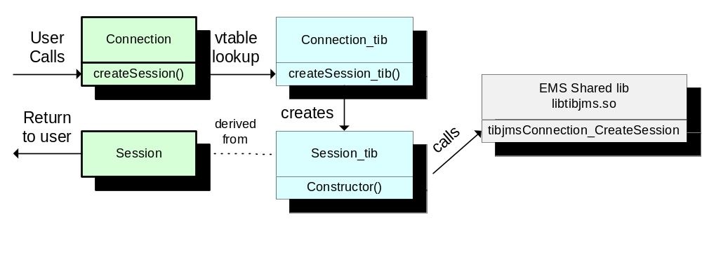

Library Structure
The library structure is show below. The client app has only one dependency, the Naming Library. The Naming library dynamically loads the C++ Wrapper library. The C++ wrapper library is dependant on the vendor specific library, in this case the EMS shared library libtibjms.so.
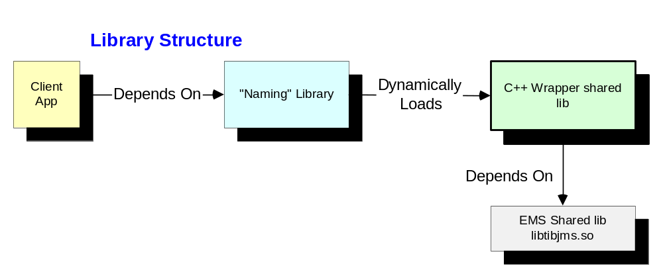

C++ Wrapper Namespace
C++ namespaces are used to guarantee unique references to globally defined objects. For example, in the standard C++ library, all classes and functions are defined within the namespace “std”. Programmers can reference these objects using the namespace such as in std::cout << “X”, without worrying about another class also implementing a cout method. Use of namespaces also prevents redefinition errors caused when a new class is added to a project that contains an object with a name already is use

The C++ Wrapper is largely encompassed by the JMS namespace. All of the objects can be referenced as JMS::Session or JMS::Destination. If a programmer knows that there will not be any naming conflicts with other classes, then they can code the using namespace JMS; directive and avoid the need to prefix objects with “JMS::”.
The C++ Wrapper also contains several helper classes contained in the LCD namespace. This seems to have been named after the class’ author. We intend to rename this namespace to a more functionally descriptive name.

C++ Wrapper Implementation Lookup
The C++ Wrapper provides a mechanism for dynamically loading a specified C++ wrapper implementation. This level of indirection separates interface from implementation and enables the support of potentially multiple JMS (e.g. IBM’s JMS implementation over MQSeries).
As mentioned earlier in Section 2.3 above, this lookup is really more of a dynamic load of the underlying wrapper implementation of the JMS vendor than a JNDI lookup of an administered object (e.g. ConnectionFactory or Destination). It is recommended that the component be renamed to accurately reflect its function.
This functionality is represented in a “Naming” library that contains a connection_factory_lookup() method. This library is link-edited with the client application. An application calls this function passing as a string parameter as the name of the wrapper library that the client wishes to use. This function returns a ConnectionFactory object that can then be used to create a connection.
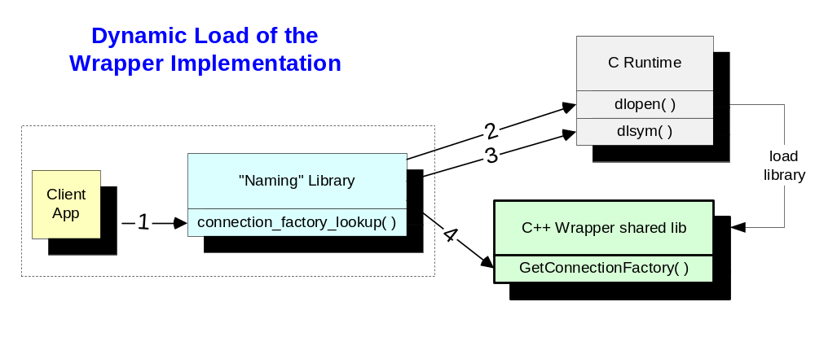Process Flow
- Client App creates instance of “Naming” class and calls connection_factory_lookup() passing the name of the C++ wrapper shared library as a parameter, e.g. "AthenaJMSRW_1_1D.so".
- The Naming library connection_factory_lookup() method then calls the C runtime dlopen( ) function to load the C++ wrapper implementation shared library.
- If the shared library is loaded successfully the “Naming” library connection_factory_lookup() method calls C runtime dlsym( ) on the GetConnectionFactory function. The C++ wrapper implementation shared library must provide this function.
- If the address of GetConnectionFactory( ) is returned successfully then the “Naming” object connection_factory_lookup() method calls the GetConnectionFactory( ) method and returns the ConnectionFactory back to the client app. The client can now use the ConnectionFactory method to create a Connection.

C++ Wrapper Class Hierarchy
For readers interested in the internal structure and class hierarchy of the wrapper, please refer to the Appendix.

What does the Wrapper API Look Like

Asynchronous Subscriber Example
The code below is a working example of a asynchronous subscriber using the C++ Wrapper. It expects to receive JMS TextMessages which it outputs to the screen.

// JMS.h contains the abstract classes that define the JMS interface.
// Naming.h contains the dynamic loader that allows a specified
// version of C++ Wrapper to be used.
#include "JMS.h"
#include "Naming.h"

#include <iostream>
#include <string>
#include <iomanip>

using namespace std;

// Derive an exception listener from JMS::iExceptionListener.
// JMS::iExceptionListener is an abstract class with no reference
// counting.
// The onException() method must be provided by the derived class.
// In this case it just outputs the exception error message.
class myExceptionListener : public JMS::iExceptionListener
{
public:
void onException (JMS::JMSException const & m);
};

void myExceptionListener::onException (JMS::JMSException const & je)
{
cout << je.what() << endl;
}

// Derive an message listener from JMS::iMessageListener.
// JMS::iMessageListener is an abstract class with no reference
// counting.
// The onMessage() method must be provided by the derived class.
class myMessageListener : public JMS::iMessageListener
{
public:
myMessageListener() {};
void onMessage (JMS::Message m);
};

// This callback function is called when a message is received.
// If we know the type of the message we can just implicitly cast to
// the correct mesasge type, in this case a TextMessage and then call
// the TextMessage specific getText() method.
// As per the JMS Specification
// (see http://edocs.bea.com/wls/docs70/faq/jms.html - 252745),
// messages are passed by value to the onMessage method. In this
// way a consumer can not change the contents of a message that may
// be held by other consumers or by the message producer.

void myMessageListener::onMessage (JMS::Message m)
{
JMS::TextMessage message = m;
cout << message->getText() << endl;
}

int main (int argc, char** argv)
{
try
{
// The JMS namespace is defined by the C++ Wrapper.
// Internally the wrapper also uses LCD namespace.
// This namespace is the initials of the original developer
// and not related to Legal and Compliance Department!
using namespace JMS;

// Load the C++ Wrapper named AthenaJMSRW_1_3D.dll.
// If this fails an exception will be thrown and be
// caught by the try/catch block.
Naming n;
ConnectionFactory factory =
n.connection_factory_lookup("AthenaJMSRW_1_3D.dll");

// Set up various connection parameters and create the
// connection.
// The clientID must be unique across multiple clients
// connecting to a specified EMS server.
factory->set_clientID("sub");
factory->set_host("tcp://slon11d10142:7222");
factory->set_user("");
factory->set_pwd("");
Connection connection = factory->createConnection();

// Set the exception listener into the Connection.
myExceptionListener myEL;
connection->setExceptionListener (&myEL);

// Create a Session. The Connection object acts as a factory
// for creating a Session. The first parameter value of false
// indicates the Session is non-transacted and the second
// parameter value of Session::NO_ACKNOWLEDGE is a Tibco
// delivery mode extension that specifies that consumer
// clients do not send an acknowledge receipt back to the
// server.
Session session =
connection->createSession(false,
Session::NO_ACKNOWLEDGE);

// Create a Destination. The Session object acts as a factory
// for creating a Destination. This can either be a Topic or
// Queue destination.
Destination requestDestination;
requestDestination = session->createTopic ("sample.topic");
// requestDestination = session->createQueue(“sample.queue");

// Create a MessageConsumer. The Session object acts as a
// factory for creating a MessageConsumer.
MessageConsumer msgConsumer =
session->createConsumer(requestDestination);

// Create a Message Listener and set into the
// MessageConsumer.
myMessageListener myML;
msgConsumer->setMessageListener (&myML);

// Start the connection. The connection must be started
// before messages can be published or subscribed.
connection->start();

// wait for messages
int i;
cin >> i;
}

// The catch logic for catching JMS and STL exceptions.
Catch (JMS::JMSException & je)
{
cout << je.what() << endl;
}
catch (std::exception & se)
{
cout << se.what() << endl;
}

return 0;
}

Publisher Example

// JMS.h contains the abstract classes that define the JMS interface.
// Naming.h contains the dynamic loader that allows a specified
// version of C++ Wrapper to be used.
#include "JMS.h"
#include "Naming.h"

#include <iostream>
#include <string>
#include <iomanip>

using namespace std;

// Derive an exception listener from JMS::iExceptionListener.
// JMS::iExceptionListener is an abstract class with no reference
// counting.
// The onException() method must be provided by the derived class.
// In this case it just outputs the exception error message.
class myExceptionListener : public JMS::iExceptionListener
{
public:
void onException (JMS::JMSException const& m);
};

void myExceptionListener::onException (JMS::JMSException const& je)
{
cout << je.what() << endl;
}

int main (int argc, char** argv)
{
try
{
// The JMS namespace is defined by the C++ Wrapper.
// Internally the wrapper also uses LCD namespace.
// This namespace is the initials of the original developer
// and not related to Legal and Compliance Department!
using namespace JMS;

// Load the C++ Wrapper named AthenaJMSRW_1_3D.dll.
// If this fails an exception will be thrown and be
// caught by the try/catch block.
Naming n;
ConnectionFactory factory =
n.connection_factory_lookup("AthenaJMSRW_1_3D.dll");

// Set up various connection parameters and create the
// connection.
// The clientID must be unique across multiple clients
// connecting to a specified EMS server.
factory->set_clientID("pub");
factory->set_host("tcp://slon11d10142:7222");
factory->set_user("");
factory->set_pwd("");
Connection connection = factory->createConnection();

// Set the exception listener into the Connection.
MyExceptionListener myEL;
connection->setExceptionListener (&myEL);

// Create a Session. The Connection object acts as a factory
// for creating a Session. The first parameter value of false
// indicates the Session is non-transacted and the second
// parameter value of Session::NO_ACKNOWLEDGE is a Tibco
// delivery mode extension that specifies that consumer
// clients do not send an acknowledge receipt back to the
// server.
Session session =
connection->createSession(false,
Session::NO_ACKNOWLEDGE);

// Create a Destination. The Session object acts as a
// factory for creating a Destination. This can either be a
// Topic or Queue destination.
Destination requestDestination;
requestDestination = session->createTopic("sample.topic");
// requestDestination = session->createQueue(“sample.queue");

// Create a MessageProducer. The Session object acts as a
// factory for creating a MessageProducer.
MessageProducer msgProducer =
session->createProducer(requestDestination);

// Create a TextMessage and add some text.
// The Session object acts as a factory for creating a
// TextMessage.
TextMessage message = session->createTextMessage();
message->setText("Hello There");

// Start the connection. The connection must be started
// before messages can be published or subscribed.
connection->start();

// Publish the message.
msgProducer->send(message);
}

// The catch logic for catching JMS and STL exceptions.
Catch (JMS::JMSException & je)
{
cout << je.what() << endl;

}
catch (std::exception & se)
{
cout << se.what() << endl;
}

return 0;
}

Proposal

Summary
This section details the proposal for adopting the Athena C++ wrapper as the strategic C++ interface for EMS.
Building upon the considerable foundation for JMS support provided by the Athena C++ wrapper, we propose that we adopt the wrapper as the standard C++ interface to JMS. We intend to package and deploy the API for all supported platforms
The proposal specifies several areas that will require changes to the code. These include the addition of a JNDI lookup feature for connections and destinations, upgrade of the wrapper to use the new EMS 4.0 headers and libraries, proposal for enhancements to the SmartPointer logic, and proposal for the removal of the STL dependency. The last two items are presented in detail further below, and they will necessitate changes to the C++ wrapper public interface classes. This means that existing applications would be affected and would have (minimal) work to rebuild with the new C++ wrapper.
The proposal also contains expansion of the STL support, additional build platforms, documentation, and packaging/deployment strategies.
Various potential modifications are being reviewed in order to simplify maintenance and improve performance and ease of use. Among the subjects that will be reviewed are:
- The use of SmartPointers. These are implemented in the C++ wrapper in order to provide a more java-like experience. Specifically, the wrapper itself can manage all created objects and the caller does not need to worry about cleaning up allocated storage. The current SmartPointer classes may be replaced by a more robust library such as the highly regarded public-domain library known as the Boost API (http://www.boost.org/libs/smart_ptr/smart_ptr.htm).
- We are also reviewing the reliance on the STL (Standard Template Library). This is part of the public interface and provides support primarily for strings. Depending on the number of STL versions in use by the MWG audience, use of STL may greatly complicate the matrix of builds supported by the C++ wrapper. This subject is presented in detail on section 6.4.5 later in this section.
- The C++ wrapper makes heavy use of C templates, which complicate maintenance and debugging. We intend to review the design with the Athena developers to better understand the rationalization for its use and to consider methods of simplifying the overall architecture.

STL Support
The choice of STL is not a significant issue for the C++ wrapper, which makes limited use of STL classes both externally and internally. Note, however, that each STL vendor and version will require a separate build.
Possible STL Support Matrix (applicability of each listed item TBD by MWG)
STLPort 4.5.3 | Currently used by Athena
STLPort 4.6 | Latest stable version
SourcePro ED3 | In use at CSFB
SourcePro ED4 | In use at CSFB
SourcePro ED5 | In use at CSFB. Has shown dramatic performance benefits when built with a specific RW macro
SourcePro ED6 | Latest version
EDG_STL | In use at CSFB – lots of versions in SCM – which ones do we support if any.
FPCore, EDG_RW | Check if these use STL
Compiler Supplied | All three platforms provide an STL implementation that is supplied with the compiler.
There are currently four versions of RogueWave SourcePro available in CSFB: Edition 3, 4, 5 and 6.
- Do we need support all four versions or only a subset?
STLPort is an OpenSource product; see http://www.stlport.com
The current version in use at CSFB is 4.5.3 (the version the Athena wrapper is built against). The latest version is 4.6.1. What would be our strategy for supporting that latest and future STLPort releases?

Platform/Compiler Support
Platform and Compiler are normally specified as a combination to leave no doubt as to which OS and version of a compiler a developer should use. The SCM release vob is also structured in this way e.g. solaris2.8-sunpro5.3. There can be more than one compiler per platform but this will obviously increase the number of supported builds.
The C++ wrapper will be initially delivered on three platforms:
- Solaris 8
- Linux RedHat
- Windows NT / 2000
with the following compiler support:
Platform | Compiler | Notes
Solaris 2.8 | SunPro 5.3 | Same as Forte 6 update 2
Linux RH AS 2.1 | gcc 3.04 | We plan to support gcc 3.2
Windows NT / 2000 | Visual Studio 6
Windows .NET | C++ Managed Code | Supported by the C# Assembly provided by Tibco
Windows .NET | C++ Unmanaged Code | We do not know of any CSFB C++ development being done in unmanaged code using VS-2003.  If there is a need, we can determine if a separate library is required, or can they still call into VS-6 libraries
Issues:
- Q: will a Solaris 2.8 / SunPro 5.2 (Forte 6 update 1) build be required?
- Q: what is the future plans for migrating to gcc 3.2 on Linux?
- Q: is support required for gcc 2.96 on Linux?

Enhancements

Add JNDI lookup from EMS
The C++ Wrapper does not currently support lookup of ConnectionFactory and Destination administered objects. The C API does support a set of API’s that provide lookup of these objects from the EMS repository. A C++ wrapper class needs to be developed to wrap these function calls and expose them.
It is recommended as a best practice that applications externalize connection and destination information in a JNDI rather than hardcoding it within the application program itself. This offers the following benefits:
- Changes to this information can be made from a central location (e.g. changes to connection information could be adjusted in a single place and point a set of applications to a different EMS server or establish a new fault tolerant backup server).
- Changes to connection and destination information will not require modifications to application source code.

Support for the latest Tibco Release: EMS 4.0
The wrapper will be modified (if necessary) to support version 4 of EMS from Tibco. This enhancement highlights one of the benefits of using the wrapper. Applications using the wrapper will gain all the benefits of the new release without any code changes.

Reconnect Logic
This is not supported in either the current Tibco C API or Athena C++ wrapper implementation. This value added feature was identified by the Athena development team. The feature would, as its name implies, enable the C++ wrapper to automatically attempt to reconnect to the EMS broker when the connection to the broker is lost. The number of retry iterations and retry interval may be specified.

Clone Message
JMS messages cannot be shared across Sessions or threads. This is explicitly stated in the JMS specification. The Clone Message feature would give us this capability by allowing a message created in one Session to be re-created for use in another Session or thread. This requirement was identified by the Athena development team.

Proposal: Removal of the STL Dependency
The use of the STL “string” class in the C++ wrapper interface dictates that applications using the C++ wrapper must use the same version of STL as the wrapper. This requirement increases the complexity of the wrapper build matrix and results in a different build of the wrapper for every application that uses a different version of the STL. If use of the STL could be removed from the interface then this complexity is eliminated. There are several ways of achieving this:
- Pass strings as char * or wchar *
- Implement a string class as part of the C++ wrapper
Use of char * or wchar * is the simplest approach but would require memory cleanup to be managed by the application (i.e. the returned string would need to be deleted). A very simple “string” class could be build around the char * string to facilitate this. Users of the string would then construct their own STL string from the returned char *.
Implementing a separate string class for the C++ wrapper is not ideal, however, this could greatly reduce the amount of supported C++ wrapper builds. This is really only an issue if the required number of STL variants is large. This topic should be addressed during the ratification process by participants in the MWG.

Proposal: Re-Work SmartPointers
The current C++ Wrapper uses Counted Pointers, which employs macros and auto pointers to present the C++ wrapper API as a Java like interface. However, part of the scope of creating an enterprise offering around the C++ wrapper is to optimize the usability and readability of the implementation. One idea here is to make the wrapper more Java like by using smart references rather than smart pointers, i.e. the . dot operator is used instead of the -> operator. This is shown in the following:

// Current Athena C++ wrapper uses -> operator
Session session =
connection->createSession (false,
Session::AUTO_ACKNOWLEDGE);

// Use smart references rather than smart pointers
// can then use . operator
Session session =
connection.createSession (false,
Session::AUTO_ACKNOWLEDGE);

An example of this kind of use is the Xerces 1.7 API, which emulated Java bindings.
We would also look at the possibility of using a third party library to provide Smart Pointer support, such as Boost, http://www.boost.org. to eliminate the homegrown smart pointer structures.

Documentation
A User’s Guide and a Reference Guide will be delivered with the final product. The Reference Guide will closely resemble the standard JMS guide. The User’s Guide will provide a “how to” approach to using the C++ interface, which is an improvement over the existing Tibco documentation.

Packaging and Distribution
The final product will include packaging and distribution for all environments plus deployment to SCM. This includes header files and libraries for all supported versions of Unix compilers and STL libraries. It will also include libraries for Linux and Windows.

Possible Future Enhancements
EMS Admin API – the C API currently does not support the EMS Admin API, which is used to obtain run-time statistics from the EMS Broker as well as execute commands against the Broker. The Admin API is currently only available in the Java language binding. It has been requested that Tibco work toward API parity across all of their supported language bindings. Once the Admin API becomes available in the C API this functionality can be exposed in a set of classes in the C++ wrapper.

Appendix A: Class Internal Structure

Class Hierarchy
This section shows the class hierarchy of some of the C++ wrapper classes. The complexity of these classes is only at the implementation level and not at the user level as can be seen from the above example code. When run through a debugger however, the implementation classes will be visible to the user.

Message Class Hierarchy
The diagram below shows the class hierarchy of the TextMessage_tib. This is an implementation class and is not exposed to the user.
The TextMessage class that the user sees is defined as a typedef.

typedef auto_ptr_ref Message_imp<iTextMessage> TextMessage

Internally the wrapper also uses LCD namespace. This namespace is the initials of the original developer and not related to Legal and Compliance Department!
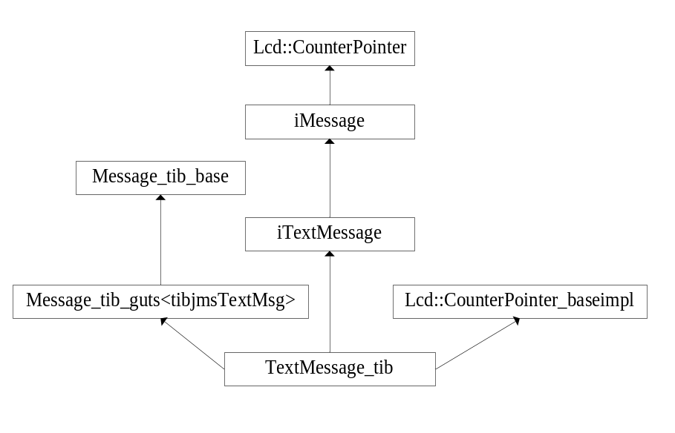

Message_tib_base. Base class that implements the abstract methods defined in iMessage. These methods are common to all derived JMS Message types, TextMessage, BytesMessage and MapMessage. This class wraps the EMS C API functions common to all Message types..
Message_tib_guts<tibjmsTextMessage>. Template class that expands based on the parameterization of derived class Message_tib. It maintains a pointer to the Tibco message type, in this case a tibjmsTextMsg.
TextMessage_tib. Non-template class that provides TextMessage specific implementation. This class wraps the EMS C API functions specific to a TextMessage.
iTextMessage – Abstract class that defines a set of pure virtual functions specific to the JMS TextMessage.
iMessage – Abstract base class that defines the interface for JMS Message.

Lcd::CountedPointer and Lcd::CounterPointer_baseimpl – These two classes provide automatic memory management of TextMessage_tib objects. They provide AddRef() and ReleaseRef() methods that are used to increment and decrement a reference count. However these methods are private and are called implicitly which means reference counting is done automatically.
The TextMessage class seen by the user is defined as as auto_ptr_ref template as shown below. This is another counted pointer that will cause the underlying implementation object TextMessage_tib to be deleted when the reference count reaches 0
It has the following class hierarchy:

auto_ptr_ref_counter

Counted pointer to a textMessage_tib
Contains a
auto_ptr_ref_base<iTextMessage>

auto_ptr_ref<iTextMessage>

.

Session Class
The Session_tib class is defined in a similar way to the TextMessge_tib
Lcd:CounterPointer

iSession

Lcd:CounterPointer_baseimpl
Session_tib_base

Session_tib

The Session class that the user sees is defined as below. Session is a class that holds a counted pointer to the Session_tib class defined above.

auto_ptr_ref_counter

Contains a
Counted pointer to a Session_tib
Auto_ptr_ref_base<iSession>

auto_ptr_ref<iSession>

Session

NOTE
All the other classes in the C++ wrapper are defined in similar ways to the above.

Version 4.0 became generally available as of February 2004. Previously versions of the product were known as “Enterprise for JMS” (E4JMS).
Serialize – refers to the ability to convert an Object, and its state, into a stream of bytes that can be persisted to disk or sent to another machine where that stream can be deserialized and converted back into a copy of the original object.
JNDI - Java Naming and Directory Interface. This facility is used by JMS to externalize configuration information for ConnectionFactories and Destinations, known as “administered objects” so that applications do not need to hardcode JMS addressing information, such as the URL of a JMS broker.

